Different methods to solve exponential equation

PPS – GVC – Math – Advance Algebra



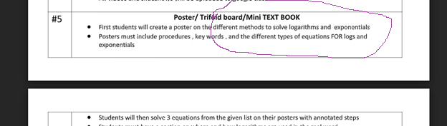

Solving the exponential equation

$$2∙3^{4x+5}=6∙7^{8x-9}$$

**Method 1**: Common base

Divide by 2 $$3^{4x+5}=3∙7^{8x-9}$$

Convert 7 to the same base 3 7 $=3^{\log_{3}{7}}$

Rewrite the equation with same base

$$3^{4x+5}=3^{1}∙3^{\log_{3}{7(8x-9)}}$$ Apply exponential property: product

$$3^{4x+5}=3^{1+\log_{3}{7(8x-9)}}$$

***Cancel the base***

$4x+5={1+log}_{3}{7(8x-9)}$

Distribute and separate variable

$${(log}_{3}{7)\left(8)(x\right)-4x=4+9}\log_{3}{7}$$

Factor and solve for x

$$x=\frac{4+9\log_{3}{7}}{8\log_{3}{7}-4}≈1.96079…$$

**Method 2**: Using logs

Divide by 2 $$3^{4x+5}=3∙7^{8x-9}$$

***Take log both sides, use common log***

$${log(3}^{4x+5})=log(3∙7^{8x-9})$$

Apply logarithm property

$$\left(4x+5\right)\log\left(3\right)=\log\left(3\right)+\left(8x-9\right)log⁡(7)$$

Distribute and separate variable

$$8\log\left(7\right)x-4\log\left(3\right)x=9\log\left(7\right)+5\log\left(3\right)-log⁡(3)$$

Factor and solve for x

$$x=\frac{9\log\left(7\right)+5\log\left(3\right)-log⁡(3)}{8\log\left(7\right)-4log⁡(3)}≈1.96079…$$

**Method 3**: Use Exponential Properties

2 times 3 raised to the 4 x plus 5 power equals 6 times 7 raised to the 8 x minus 9 power⁣

Divide by 2. Apply exponential property. Apply cross multiply property to separate variable

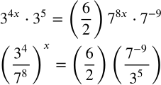

Apply inverse property to solve for x

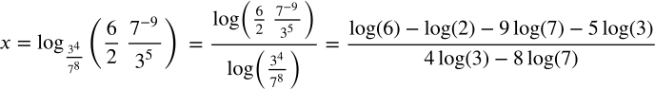

$$≈1.96079…$$

**Method 4**: Graphing method

Graph the exponential function of the left side, then the right side.

Locate the intersection of these two $$x ≈1.961…$$

